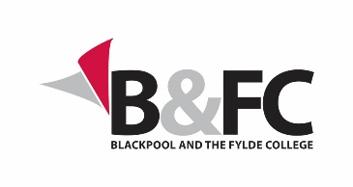
Blackpool & The Fylde College

Admission Appeals Form

Please read thoroughly Section B14: Admission Appeals of Blackpool and The Fylde College’s Taught Award Regulations before submitting this form, the regulations can be found here: https://www.blackpool.ac.uk/he-regulations
Applicants to Blackpool and The Fylde College Higher Education programmes whose application has been rejected have the right of appeal if an applicant:
- believes that they have received discriminatory treatment compared to other applicants for the same programme with the same entry requirements
and/or
- believes that Blackpool and The Fylde College has not adhered to its own stated policy and/or procedures for the processing of applications
and/or
- has mitigating circumstances information that was unavailable at the point of application

Submit your appeal by either emailing it to admissions@blackpool.ac.uk or hand it to any campus reception area, this must be completed within 10 working days of the initial rejection decision.

Details
Full Name:
Programme to which you are applying:
Address for correspondence:
Tel no: |  | Mobile no:
E-mail:

About Your Appeal
- Please provide details of your admission appeal

Declaration:
I declare that the information given in this form is true and that I have consulted the Procedure before completing the form.

Signed: Date:

Note:
- The College will endeavour to maintain confidentiality in relation to your admission appeal but, in order for it to be considered fully, the content may need to be disclosed to colleagues who are involved in enacting the Procedure as well as colleagues whose involvement may be required to respond to the issues you have raised.
- By signing the declaration above you are consenting to the disclosure and sharing of information relevant to the admission appeal within the College at all stages of the Procedure.

